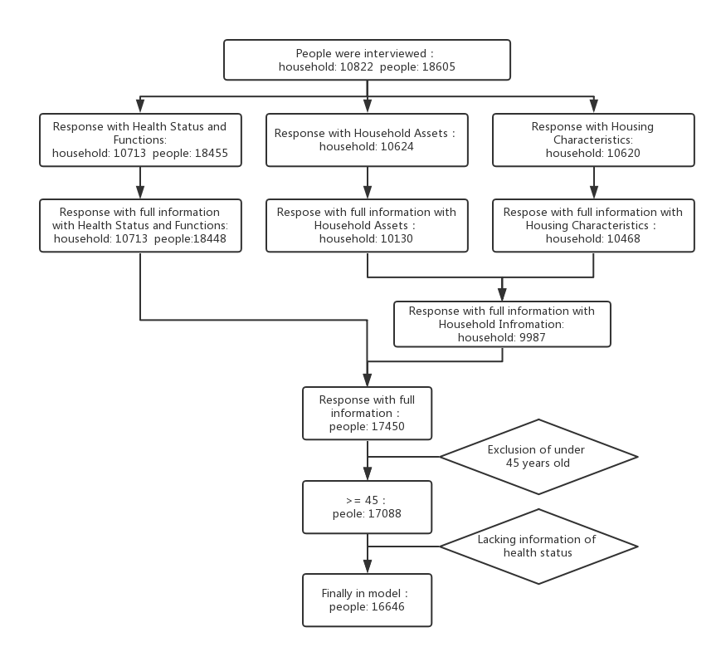

Figure S1 Flow chart of the sample selection process, 2011–2012
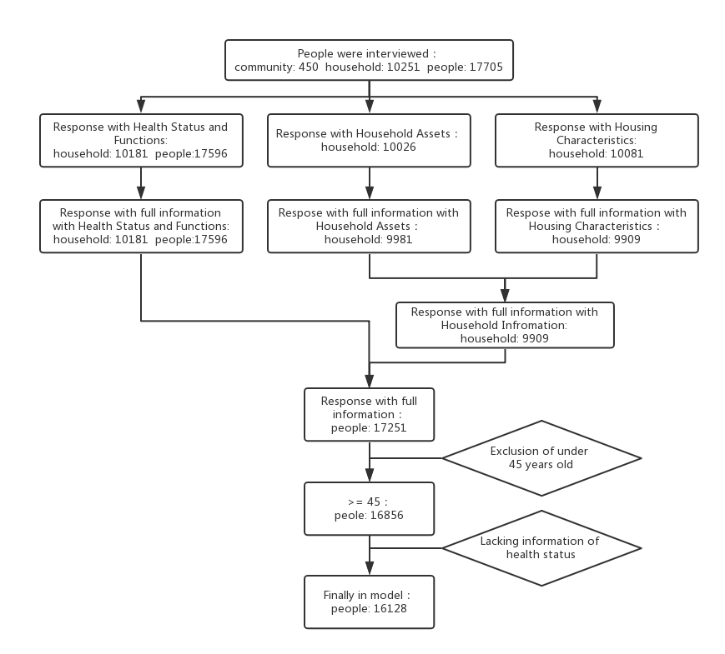

Figure S2 Flow chart of the sample selection process, 2013–2014
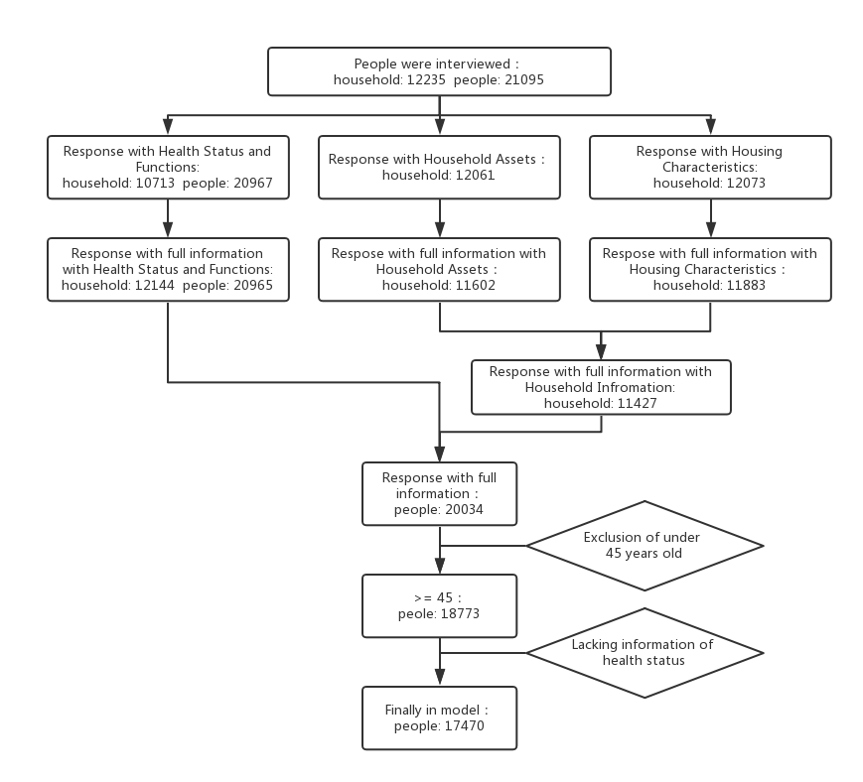

Figure S3 Flow chart of the sample selection process, 2015–2016
Table S1 The Results of Principal Component Analysis
 | The First Eigenvector
 | 2011 | 2013 | 2015
Cumulative Proportion, % | 0.1498 | 0.1511 | 0.1416
Automobile | 0.1131 | 0.1428 | 0.1486
Electric bicycle | 0.0832 | 0.0929 | 0.1009
Motorcycle | 0.0264 | 0.0349 | 0.0348
Refrigerator | 0.2250 | 0.2049 | 0.1994
Washing machine | 0.1981 | 0.1884 | 0.2033
Tv | 0.1066 | 0.1008 | 0.1123
Computer | 0.2522 | 0.2565 | 0.2662
Stereo system | 0.0910 | 0.1203 | 0.1201
Video camera | 0.0895 | 0.1134 | 0.1219
Camera | 0.1832 | 0.2010 | 0.1875
Air conditioner | 0.2369 | 0.2397 | 0.2521
Mobile phone | 0.1227 | 0.1182 | 0.1181
Furniture | 0.0483 | 0.0787 | 0.0829
Music instrument | 0.0498 | 0.0603 | 0.0685
Valuable decorations, ornaments | 0.0321 | 0.0440 | 0.0399
Treasures and precious metal | 0.0761 | 0.1224 | 0.1120
Antiques, valuable paintings and calligraphic work, and other artistic work | 0.0296 | 0.0375 | 0.0574
Building structure
Concrete and steel | 0.2240 | 0.2231 | 0.1961
Bricks and wood | −0.1242 | −0.1423
Mixed structure | 0.0031 | 0.0117
Wood, bamboo, grass | −0.0540 | −0.0397 | −0.0459
Woolen felt | −0.0073 | −0.0100 | −0.0137
Sheet iron | −0.0041 | −0.0039 | −0.0681
Cave dwelling | −0.0429 | −0.0414 | −0.0469
Tent | 0.0037 | 0.0000
Adobe | −0.1032 | −0.1036 | −0.1600
Other | −0.0240 | −0.0314 | −0.0327
One-story building | −0.2464 | −0.2518 | −0.2169
Multi-story building | 0.2464 | 0.2518 | 0.2174
Toilets | 0.1608 | 0.1561 | 0.1597
Running water | 0.1869 | 0.1573 | 0.1585
Shower or bath facility
Hot water provided | 0.0574 | 0.0277 | 0.0249
Water heater installed by the household | 0.2777 | 0.2774 | 0.2850
No | −0.2873 | −0.2819 | −0.2911
Coal gas or natural gas | 0.2196 | 0.2070 | 0.2098
Heating | 0.1718 | 0.1362 | 0.1355
Main source of cooking fuel
Coal | −0.0454 | −0.0554 | −0.0629
Natural gas | 0.2060 | 0.2052 | 0.2115
Marsh gas | −0.0028 | −0.0073 | −0.0037
Liquefied petroleum gas | 0.1056 | 0.0718 | 0.0724
Electric | 0.0314 | 0.0280 | 0.0131
Crop residue/wood burning | −0.2046 | −0.1999 | −0.2159
Other | −0.0242 | −0.0126 | −0.0063
Telephone connection | 0.1236 | 0.1165 | 0.1170
Internet connection | 0.2497 | 0.2538 | 0.2614

Table S 2 Prevalence (95% confidence interval) of 14 chronic diseases by wealth tertiles, 2011–2012
 | All | Poorest tertile | Middle tertile | Richest tertile | Adjust P
Hypertension | 24.6 (23.9-25.3) | 24.7 (23.5-25.8) | 23.1 (22-24.3) | 26 (24.8-27.2) | <.0001
Dyslipidaemia | 9.3 (8.8-9.7) | 6.9 (6.3-7.6) | 7.4 (6.7-8.1) | 13.5 (12.6-14.4) | <.0001
Diabetes or high blood sugar | 5.8 (5.4-6.2) | 4.6 (4-5.2) | 5.1 (4.5-5.7) | 7.6 (6.9-8.4) | <.0001
Cancer or malignant tumour | 0.9 (0.8-1.1) | 0.7 (0.5-1) | 0.9 (0.6-1.1) | 1.2 (0.9-1.4) | 0.0006
Chronic lung diseases | 10.1 (9.6-10.6) | 13.2 (12.3-14.1) | 9.9 (9.1-10.7) | 7.2 (6.5-7.9) | <.0001
Liver disease | 3.9 (3.6-4.2) | 4.5 (4-5.1) | 3.4 (2.9-3.9) | 3.7 (3.2-4.2) | 0.0053
Heart disease | 11.9 (11.4-12.4) | 13.6 (12.6-14.5) | 10.4 (9.6-11.3) | 11.7 (10.8-12.5) | <.0001
Stroke | 2.4 (2.1-2.6) | 2.6 (2.2-3) | 2.1 (1.7-2.5) | 2.4 (2-2.8) | <.0001
Kidney disease | 6.3 (5.9-6.7) | 7.5 (6.8-8.2) | 6 (5.4-6.6) | 5.5 (4.9-6.1) | <.0001
Stomach or other digestive disease | 21.8 (21.1-22.4) | 23.8 (22.7-24.9) | 22.7 (21.6-23.8) | 18.9 (17.8-19.9) | <.0001
Emotional,nervous,or psychiatric problems | 1.4 (1.2-1.5) | 2.1 (1.7-2.4) | 1.1 (0.8-1.4) | 0.9 (0.6-1.1) | <.0001
Memory_related disease | 1.5 (1.3-1.7) | 1.9 (1.6-2.3) | 1.2 (0.9-1.5) | 1.5 (1.1-1.8) | <.0001
Arthritis or rheumatism | 32.5 (31.8-33.2) | 37.9 (36.6-39.2) | 34.8 (33.5-36.1) | 24.8 (23.6-25.9) | <.0001
Asthma | 3.6 (3.3-3.9) | 4.9 (4.3-5.5) | 3.4 (3-3.9) | 2.5 (2.1-2.9) | <.0001

Table S3 Prevalence (95% confidence interval) of 14 chronic diseases by wealth tertiles, 2013–2014
 |  | All | Poorest tertile | Middle tertile | Richest tertile | Adjust P
Hypertension |  | 28.2 (27.6-28.9) | 28.8 (27.6-30) | 27.6 (26.4-28.7) | 28.3 (27.2-29.5) | <.0001
Dyslipidaemia |  | 12.3 (11.8-12.8) | 8.9 (8.1-9.6) | 11.2 (10.3-12) | 16.8 (15.9-17.8) | <.0001
Diabetes or high blood sugar |  | 7.6 (7.2-8) | 6.1 (5.5-6.8) | 6.7 (6.1-7.4) | 10 (9.2-10.8) | <.0001
Cancer or malignant tumour |  | 1.2 (1-1.4) | 0.9 (0.7-1.2) | 1.4 (1.1-1.7) | 1.3 (1-1.6) | 0.0005
Chronic lung diseases |  | 11.3 (10.8-11.7) | 14.1 (13.1-15) | 11.1 (10.3-11.9) | 8.6 (7.9-9.3) | <.0001
Liver disease |  | 4.4 (4.1-4.7) | 4.3 (3.8-4.9) | 4.1 (3.5-4.6) | 4.7 (4.1-5.2) | 0.0019
Heart disease |  | 13.7 (13.2-14.2) | 16.2 (15.2-17.1) | 12 (11.2-12.9) | 12.8 (11.9-13.7) | <.0001
Stroke |  | 2.9 (2.6-3.1) | 3.1 (2.6-3.5) | 2.5 (2.1-2.9) | 3 (2.6-3.5) | <.0001
Kidney disease |  | 6.8 (6.4-7.1) | 7.6 (6.9-8.3) | 6.6 (6-7.3) | 6 (5.4-6.7) | <.0001
Stomach or other digestive disease |  | 25.6 (25-26.3) | 28.5 (27.3-29.7) | 26.7 (25.5-27.8) | 21.8 (20.7-22.8) | <.0001
Emotional,nervous,or psychiatric problems |  | 1.2 (1.1-1.4) | 1.4 (1.1-1.7) | 1.2 (0.9-1.5) | 1.1 (0.8-1.4) | 0.0052
Memory_related disease |  | 1.9 (1.6-2.1) | 2.3 (1.9-2.7) | 1.6 (1.3-2) | 1.6 (1.3-2) | <.0001
Arthritis or rheumatism |  | 35.9 (35.2-36.6) | 41.7 (40.4-43) | 38.5 (37.2-39.8) | 27.6 (26.4-28.8) | <.0001
Asthma |  | 4 (3.7-4.3) | 5.5 (4.9-6.1) | 3.6 (3.1-4.1) | 3 (2.5-3.4) | <.0001

Table S4 Prevalence (95% confidence interval) of 14 chronic diseases by wealth tertiles, 2015–2016
 | All | Poorest tertile | Middle tertile | Richest tertile | Adjust P
Hypertension | 29.7 (29-30.3) | 31.5 (30.3-32.7) | 29.2 (28.1-30.4) | 28.2 (27.1-29.4) | <.0001
Dyslipidaemia | 14 (13.5-14.5) | 11.5 (10.7-12.3) | 12.5 (11.6-13.3) | 17.9 (16.9-18.9) | <.0001
Diabetes or high blood sugar | 8.6 (8.2-9) | 7.3 (6.6-7.9) | 7.7 (7-8.4) | 10.8 (10-11.6) | <.0001
Cancer or malignant tumour | 1.2 (1.1-1.4) | 0.9 (0.7-1.2) | 1.2 (0.9-1.5) | 1.6 (1.2-1.9) | <.0001
Chronic lung diseases | 10.7 (10.3-11.2) | 14.4 (13.5-15.3) | 10.3 (9.5-11) | 7.6 (6.9-8.3) | <.0001
Liver disease | 4.1 (3.8-4.4) | 4.4 (3.9-4.9) | 3.8 (3.4-4.3) | 4.2 (3.7-4.7) | 0.0005
Heart disease | 14.4 (13.8-14.9) | 16.7 (15.7-17.7) | 13.5 (12.6-14.3) | 12.9 (12-13.8) | <.0001
Stroke | 2.6 (2.4-2.8) | 3.3 (2.9-3.8) | 2.2 (1.9-2.6) | 2.2 (1.8-2.6) | <.0001
Kidney disease | 6.6 (6.2-7) | 7.7 (7-8.4) | 6.5 (5.9-7.2) | 5.6 (5-6.2) | <.0001
Stomach or other digestive disease | 23.5 (22.9-24.1) | 26 (24.8-27.1) | 25.2 (24.1-26.3) | 19.3 (18.3-20.3) | <.0001
Emotional,nervous,or psychiatric problems | 1.4 (1.2-1.5) | 2.1 (1.7-2.4) | 1.2 (0.9-1.5) | 0.8 (0.5-1) | <.0001
Memory_related disease | 2 (1.8-2.2) | 2.9 (2.4-3.3) | 1.6 (1.3-1.9) | 1.5 (1.2-1.9) | <.0001
Arthritis or rheumatism | 32.9 (32.2-33.6) | 40 (38.7-41.2) | 34.5 (33.3-35.7) | 24.1 (23-25.2) | <.0001
Asthma | 4.4 (4.1-4.7) | 6.2 (5.6-6.8) | 4.3 (3.7-4.8) | 2.7 (2.3-3.1) | <.0001

Table S5 Concentration indices of 14 chronic diseases and comorbidities in subpopulations by sex (2011–2012, 2013–2014, 2015–2016)
Disease | 2011  CI(95%CI) | 2013  CI(95%CI) | 2015  CI(95%CI)
Hypertension
Male | 0.0494 (0.0251,0.0744) | 0.02 (0.0011,0.0421) | -0.004 (-0.024,0.0164)
Female | -0.014 (-0.03,0.0074) | -0.034 (-0.054,-0.013) | -0.045 (-0.062,-0.029)
Dyslipidaemia
Male | 0.235 (0.195,0.2736) | 0.1934 (0.1571,0.2298) | 0.1667 (0.1312,0.1973)
Female | 0.1477 (0.1064,0.1848) | 0.152 (0.1198,0.1838) | 0.08 (0.0563,0.117)
Diabetes or high blood sugar
Male | 0.184 (0.1265,0.2385) | 0.1853 (0.1411,0.2313) | 0.1618 (0.1156,0.2055)
Female | 0.0944 (0.046,0.1458) | 0.086 (0.0469,0.1237) | 0.0463 (0.011,0.0839)
Cancer or malignant tumour
Male | 0.1411 (0,0.2815) | 0.0794 (-0.046,0.2043) | 0.0852 (-0.025,0.2024)
Female | 0.1022 (-0.021,0.2219) | 0.0978 (0.0005,0.2002) | 0.16 (0.0711,0.2725)
Chronic lung diseases
Male | -0.129 (-0.161,-0.093) | -0.105 (-0.137,-0.069) | -0.129 (-0.16,-0.09)
Female | -0.162 (-0.197,-0.121) | -0.148 (-0.183,-0.1) | -0.193 (-0.23,-0.156)
Liver disease
Male | -0.023 (-0.091,0.0429) | 0.0502 (-0.012,0.1082) | 0.017 (-0.041,0.0788)
Female | -0.068 (-0.133,-0.006) | -0.034 (-0.096,0.0301) | -0.068 (-0.132,-0.008)
Heart disease
Male | 0.0125 (-0.027,0.0542) | -0.012 (-0.049,0.0246) | -0.01 (-0.053,0.0178)
Female | -0.063 (-0.094,-0.033) | -0.087 (-0.116,-0.059) | -0.095 (-0.12,-0.069)
Stroke
Male | 0.0545 (-0.026,0.1317) | 0.0014 (-0.072,0.0689) | -0.07 (-0.129,-0.004)
Female | -0.075 (-0.172,0.0137) | -0.042 (-0.127,0.0456) | -0.198 (-0.279,-0.101)
Kidney disease
Male | -0.053 (-0.104,-0.006) | -0.045 (-0.093,0) | -0.077 (-0.123,-0.033)
Female | -0.103 (-0.156,-0.055) | -0.084 (-0.133,-0.038) | -0.096 (-0.14,-0.05)
Stomach or other digestive disease
Male | -0.043 (-0.068,-0.015) | -0.051 (-0.074,-0.029) | -0.05 (-0.08,0)
Female | -0.08 (-0.102,-0.058) | -0.079 (-0.098,-0.059) | -0.08 (-0.102,-0.061)
Emotional,nervous,or psychiatric problems
Male | -0.23 (-0.354,-0.114) | -0.02 (-0.165,0.097) | -0.22 (-0.331,-0.112)
Female | -0.169 (-0.261,-0.06) | -0.14 (-0.236,-0.029) | -0.23 (-0.332,-0.137)
Memory_related disease
Male | -0.094 (-0.196,0.0124) | -0.11 (-0.189,-0.03) | -0.15 (-0.242,-0.074)
Female | 0 (-0.185,0.048) | -0.112 (-0.215,-0.003) | -0.144 (-0.231,-0.051)
Arthritis or rheumatism
Male | -0.126 (-0.143,-0.108) | -0.12 (-0.138,-0.102) | -0.136 (-0.156,-0.1)
Female | -0.085 (-0.1,-0.067) | -0.087 (-0.102,-0.073) | -0.111 (-0.12,-0.09)
Asthma
Male | -0.17 (-0.229,-0.103) | -0.181 (-0.231,-0.131) | -0.181 (-0.238,-0.13)
Female | -0.145 (-0.214,-0.077) | -0.13 (-0.194,-0.059) | -0.228 (-0.282,-0.174)
Count of comorbidity
Male | -0.023 (-0.037,-0.01) | -0.02 (-0.037,-0.01) | -0.032 (-0.041,-0.003)
Female | -0.051 (-0.062,-0.038) | -0.05 (-0.062,-0.039) | -0.072 (-0.083,-0.061)

Table S6 Concentration indices of 14 chronic diseases and comorbidities in rural or urban subpopulations (2011–2012, 2013–2014, 2015–2016)
Disease | 2011  CI(95%CI) | 2013  CI(95%CI) | 2015  CI(95%CI)
Hypertension
Rural | -0.043 (-0.065,-0.021) | -0.048 (-0.066,-0.03) | -0.06 (-0.08,-0.042)
Urban | 0.0214 (-0.003,0.043) | -0.003 (-0.023,0.0181) | -0.029 (-0.048,-0.01)
Dyslipidaemia
Rural | 0.0692 (0.0255,0.1132) | 0.0852 (0.0514,0.119) | 0.0253 (-0.006,0.0546)
Urban | 0.1644 (0.1296,0.1978) | 0.1167 (0.0847,0.1493) | 0.1064 (0.0789,0.134)
Diabetes or high blood sugar
Rural | 0.0271 (-0.028,0.0841) | 0.0073 (-0.044,0.056) | 0.0186 (-0.02,0.0595)
Urban | 0.0664 (0.0205,0.112) | 0.071 (0.0341,0.1129) | 0.0481 (0.0102,0.0876)
Cancer or malignant tumour
Rural | 0.1251 (-0.004,0.2541) | 0.1049 (0.0014,0.1988) | 0.1061 (0.0097,0.2001)
Urban | 0.0648 (-0.071,0.2107) | 0.034 (-0.09,0.1576) | 0.1187 (0.0129,0.2298)
Chronic lung diseases
Rural | -0.116 (-0.149,-0.083) | -0.13 (-0.158,-0.101) | -0.149 (-0.179,-0.117)
Urban | -0.154 (-0.196,-0.106) | -0.113 (-0.151,-0.069) | -0.154 (-0.193,-0.113)
Liver disease
Rural | -0.027 (-0.079,0.0244) | -0.068 (-0.12,-0.016) | -0.097 (-0.144,-0.049)
Urban | -0.012 (-0.087,0.0635) | 0.0831 (0.0279,0.1392) | 0.0506 (-0.008,0.1159)
Heart disease
Rural | -0.135 (-0.171,-0.103) | -0.17 (-0.202,-0.142) | -0.161 (-0.193,-0.13)
Urban | -0.038 (-0.071,-0.005) | -0.05 (-0.086,-0.019) | -0.057 (-0.086,-0.026)
Stroke
Rural | -0.111 (-0.18,-0.028) | -0.117 (-0.193,-0.046) | -0.179 (-0.245,-0.114)
Urban | 0.0136 (-0.068,0.096) | -0.023 (-0.101,0.0478) | -0.096 (-0.181,-0.02)
Kidney disease
Rural | -0.064 (-0.107,-0.02) | -0.077 (-0.118,-0.031) | -0.093 (-0.129,-0.056)
Urban | -0.094 (-0.155,-0.037) | -0.076 (-0.122,-0.027) | -0.08 (-0.136,-0.03)
Stomach or other digestive disease
Rural | -0.02 (-0.043,0) | -0.043 (-0.06,-0.025) | -0.04 (-0.06,-0.022)
Urban | -0.063 (-0.091,-0.035) | -0.061 (-0.086,-0.034) | -0.076 (-0.104,-0.049)
Emotional,nervous,or psychiatric problems
Rural | -0.208 (-0.291,-0.12) | -0.159 (-0.262,-0.04) | -0.267 (-0.353,-0.176)
Urban | -0.207 (-0.323,-0.102) | -0.078 (-0.192,0.0353) | -0.221 (-0.335,-0.103)
Memory_related disease
Rural | -0.216 (-0.314,-0.11) | -0.209 (-0.289,-0.13) | -0.229 (-0.3,-0.158)
Urban | -0.049 (-0.144,0.0609) | -0.082 (-0.179,0.0198) | -0.13 (-0.231,-0.04)
Arthritis or rheumatism
Rural | -0.049 (-0.064,-0.033) | 0 (-0.075,-0.047) | -0.093 (-0.107,-0.079)
Urban | -0.131 (-0.152,-0.107) | -0.135 (-0.154,-0.11) | -0.13 (-0.153,-0.111)
Asthma
Rural | -0.167 (-0.233,-0.1) | -0.17 (-0.23,-0.129) | -0.166 (-0.217,-0.118)
Urban | -0.143 (-0.222,-0.068) | -0.13 (-0.203,-0.065) | -0.22 (-0.28,-0.157)
Count of comorbidity
Rural | -0.053 (-0.066,-0.04) | -0.064 (-0.074,-0.053) | -0.08 (-0.092,-0.07)
Urban | -0.035 (-0.04,-0.02) | -0.036 (-0.05,-0.021) | -0.05 (-0.064,-0.036)

Table S7 The association between per capita GDP among provinces and the concentration indices of 14 chronic diseases
 | R² | Kendall Tau b | P
Hypertension | 0.0002 | 0.0847 | 0.9396
Dyslipidaemia | 0.2070 | -0.2328 | 0.0150
Diabetes or high blood sugar | 0.0035 | -0.0212 | 0.7656
Cancer or malignant tumour | 0.0324 | 0.1213 | 0.3592
Chronic lung diseases | 0.0791 | -0.0741 | 0.1471
Liver disease | 0.0637 | 0.0423 | 0.1952
Heart disease | 0.0417 | -0.0476 | 0.2975
Stroke | 0.0076 | 0.0954 | 0.6716
Kidney disease | 0.2427 | -0.3545 | 0.0077
Stomach or other digestive disease | 0.0003 | -0.0582 | 0.9335
Emotional,nervous,or psychiatric problems | 0.0207 | 0.0646 | 0.4834
Memory_related disease | 0.0120 | -0.0541 | 0.5868
Arthritis or rheumatism | 0.0322 | -0.0582 | 0.3610
Asthma | 0.2416 | -0.2646 | 0.0079
Count of comorbidity | 0.0470 | -0.0741 | 0.2680

